**Assignments 14.2**

http://dev.mysql.com/doc/index-other.html("sakila database")

http://dev.mysql.com/doc/sakila/en/sakila.html(for full documentation)

Requirements

For each question, you are required to provide the following:

- The SQL query you used

- The answers

- Any assumptions you made

5. Problem Statement

1. Who is the customer who spent the most on rental movies? Return his/her customer id, first

name and the amount spent.

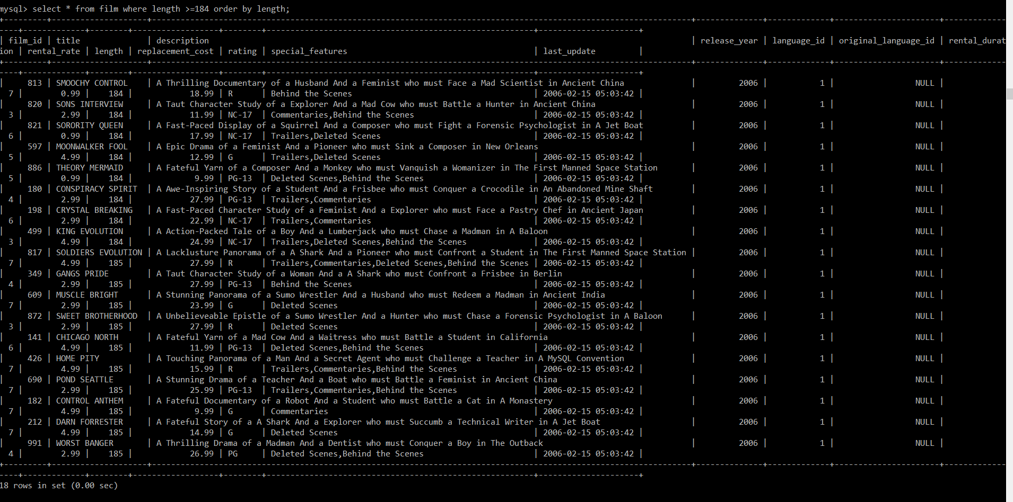

2. Give an interesting query of your own that is not already in the assignment. The query should

involve at least two joins, HAVING clause and aggregation operation. Give the English explana-

tion and the answer.

